**PHALAUN SYSTEM**

**FOR**

**EFFICENT**

**DOMESTIC WASTE COLLECTION**

SUBMITTED BY:

RAAG YATCHU MAHARJAN (ACE078BCT051)

SAMRIDHA SHRESTHA (ACE078BCT059)

SAMYOG G.C. (ACE078BCT060)

SEZJA SHRESTHA (ACE078BCT064)

**Abstract**

The Phalaun System with alerts and reward points is an innovative solution designed to address the growing challenges of waste disposal and recycling. The system provides a platform where users can efficiently manage waste disposal by segregating decomposable, non-decomposable and recyclables. Through a smart alert mechanism, users are notified when it’s time to dispose of their waste or recycle ensuring timely and accurate waste management. To incentivize recycling behavior, users earn reward points for recycling eligible items, which can be accumulated and redeemed for various benefits, including discounts or services. Additionally, it promotes interaction between the waste collector and user encouraging recycling behaviors. By integrating technology with sustainability, the system promotes environmentally responsible behavior while providing tangible rewards for contributing to waste reduction and recycling efforts.

*Decomposable*

*Non-decomposable*

*Recycle*

*Reward points*

**CHAPTER 1**

**INTRODUCTION**

**1.1 Background**

Managing domestic waste is one of the major challenges in our country. A survey conducted in all 58 municipalities of Nepal in 2012 found that the average municipal solid waste generation was 317 grams per capita per day. This translates into 1,435 tons per day or 524,000 tons per year of municipal solid waste generation in Nepal. Many of these technically and financially constrained municipalities are still practicing roadside dumping, creating major health risks.

**1.2 Problem Statement**

Waste Management is a big issue for most developing countries including our very own Nepal. Kathmandu, the capital, remains on top as the most polluted city of Nepal. There remains a gap in implementing sustainable and scalable waste management systems, especially in urban areas. People are affected on the daily due to missing the waste collection trucks. This causes accumulation of waste which is then disposed haphazardly at random places.

**1.3 Project objective**

**General Objective:**

* To promote recycling habits and end haphazard solid waste disposal behaviors.

**Specific Objectives:**

* To assess current domestic waste management practices
* To promote recycling habits
* To end haphazard domestic waste disposal

## CHAPTER 2

## SYSTEM DESIGN AND ARCHITECTURE

**1. Client-Side (Flutter App)**

* **Flutter Modules**:
  + **User Interface**: Screens for login, schedules, rewards, and alerts.

**2. Backend**

* **Backend Framework**:
  + **Firebase**

**3. Notifications and Alerts**

* Use **Firebase Cloud Messaging (FCM)** or **OneSignal** for:
  + Schedule change alerts.
  + Waste collection reminders.

**Workflow for Key Use Cases**

**1. User Login & Registration**

1. User enters credentials in the Flutter app.
2. App sends a request to the backend API for validation.
3. Backend authenticates using a database and returns a JWT token.
4. User accesses their profile and schedules post-login.

**2. View Waste Collection Schedule**

1. User opens the schedule page.
2. App fetches schedule data from the backend.
3. Schedules are displayed, with live updates using WebSockets.

**3. Alert System**

1. Admin sends an alert via the dashboard.
2. Alert is saved in the backend and pushed to the user via FCM.

**4. Rewards Management**

1. User completes a waste management task (e.g., timely waste segregation).
2. Backend logs the action and updates the user’s reward balance.

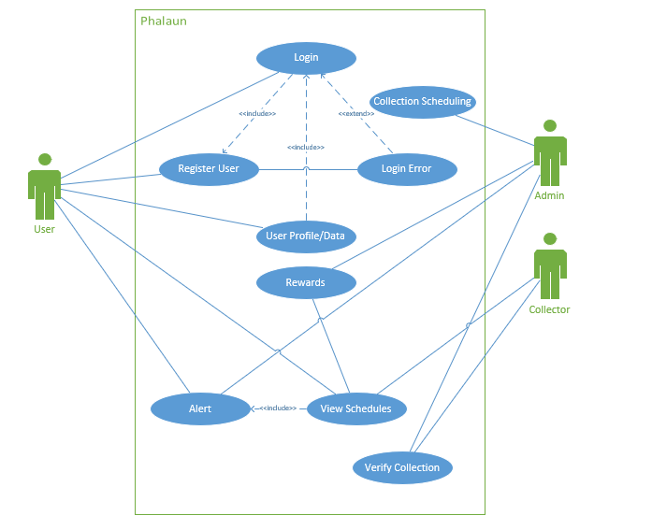

Fig: Use Case Diagram of the proposed system

## CHAPTER 3

## EXPECTED OUTPUT

The waste management system should be able to notify the users about the time of garbage collection and have the features as follows:

**3.1. Waste Collection Notification :**

The system will be able to notify the collection of waste to its various users based on or off schedule.

**3.2. Waste Collection Request:**

The system will be able to acknowledge the garbage collection request sent by users.

### 3.3. Reward based collection:

The system will be able to award reward points for segregation of waste, which can later be used to redeem gifts. The waste will be segregated into three types each containing 10 points:

* Biodegradable
* Non-biodegradable
* Recyclable

The total such points acquired will be displayed on dashboard.

## CHAPTER 4

## CONCLUSION

This system aims to manage the waste by proper scheduling of waste and rewarding the users for their effort to segregate the waste by gamification of the process. This system reduces the inconsistent behavior of garbage collection by scheduling and tracking the process. For a polluted city like Kathmandu where everyone has access to mobile phones, this app can regulate and create an initiative to make waste management more friendly and efficient.

The Phalaun System with Alerts and Reward Points represents a forward-thinking approach to tackling the challenges of waste management and recycling. By combining timely alerts, incentives for recycling the system not only encourages responsible waste disposal but also fosters a sense of community and shared responsibility. Users are empowered to make more sustainable choices through rewards, while waste collectors benefit from streamlined operations and better engagement with the community. This system is an effective tool for promoting environmental sustainability, reducing waste, and enhancing public awareness about recycling, ultimately contributing to a cleaner and greener future.

**CITATIONS:**

<https://www.adb.org/publications/solid-waste-management-nepal-current-status-and-policy-recommendations>